Entity Framework Core 8.0
Lab 1: Understanding ORM with a Retail Inventory System
Output:

Lab 2: Setting Up the Database Context for a Retail Store
Output:
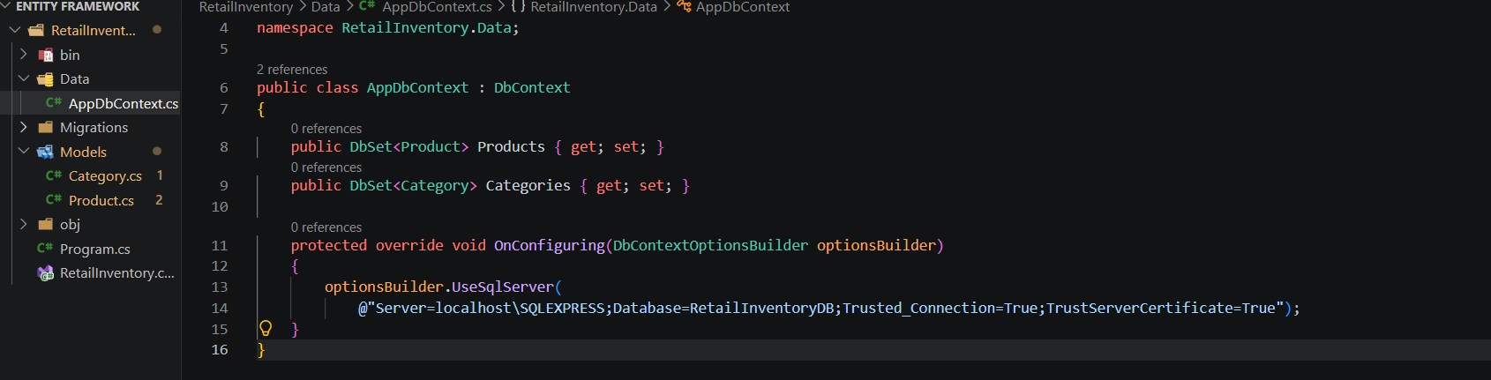

Lab 3: Using EF Core CLI to Create and Apply Migrations
Output:
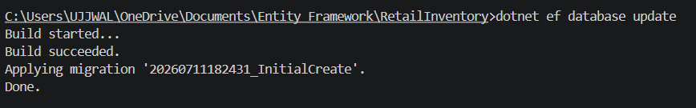
Lab 4: Inserting Initial Data into the Database
Output:
SELECT * FROM Categories;
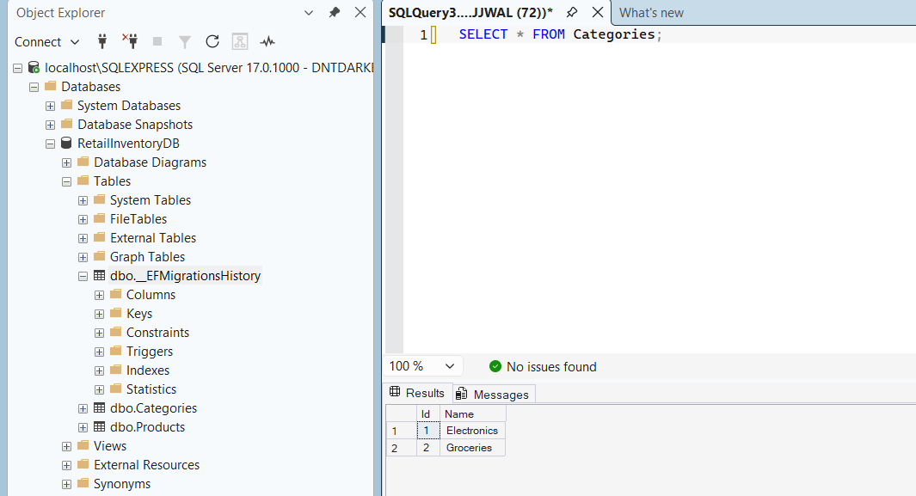
SELECT * FROM dbo.Categories;
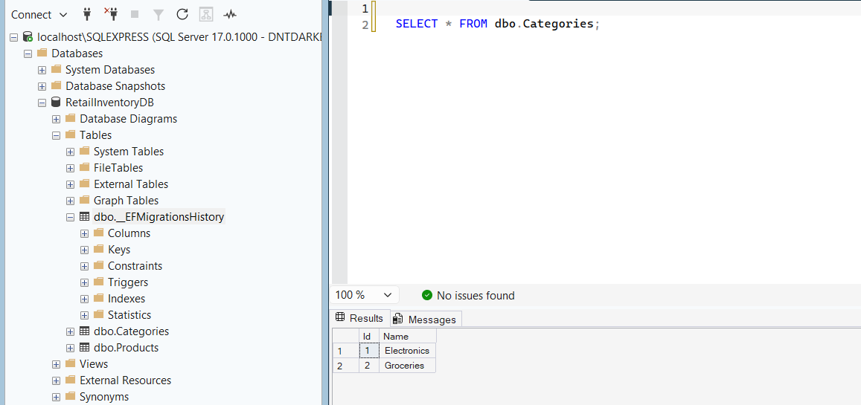

Lab 5: Retrieving Data from the Database
Output:
